SASS
Sass, SCSS инсталяция
Sass - препроцессор. Используется, когда файл со стилями (css) становится громоздким и трудно поддерживаемым.
Есть два синтаксиса Sass:
Sass синтаксис - без скобок и точки с запятой (взял правила синтаксиса из Ruby)
SCSS синтаксис - синтаксис точно такой же как классический css
Note that “Sass” is never uppercase, no matter whether we’re talking about the language or the syntax. Meanwhile, “SCSS” is always uppercase.
Sass - это название препроцессора, SassScript - язык программирования, который использует Sass.
Варианты установки:
через командную строку
Если используется NODE.js через npm
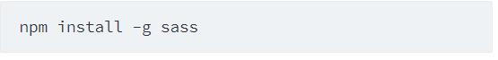
Есть и другие варианты. Прочитать можно на официальном сайте https://sass-lang.com/install
После инсталяции sass файлы с расширением .sass и .scss можно компилировать в .css
Это делается через командную строку, например:
sass input.scss output.css
пример внизу компиляция через gitBash
sass - команда для компиляции, style.scss файл с препроцессором, style.css файл который получается после компиляции.
You can also watch individual files or directories with the --watch flag. The watch flag tells Sass to watch your source files for changes, and re-compile CSS each time you save your Sass. If you wanted to watch (instead of manually build) your input.scss file, you'd just add the watch flag to your command, like so:
пример внизу использование флага watch через gitBash
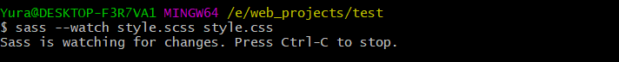
You can watch and output to directories by using folder paths as your input and output, and separating them with a colon. In this example:
Sass would watch all files in the app/sass folder for changes, and compile CSS to the public/stylesheets folder.

Переменные.
Sass uses the $ symbol to make something a variable. Here's an example:
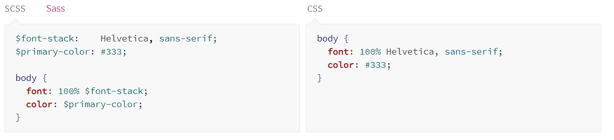
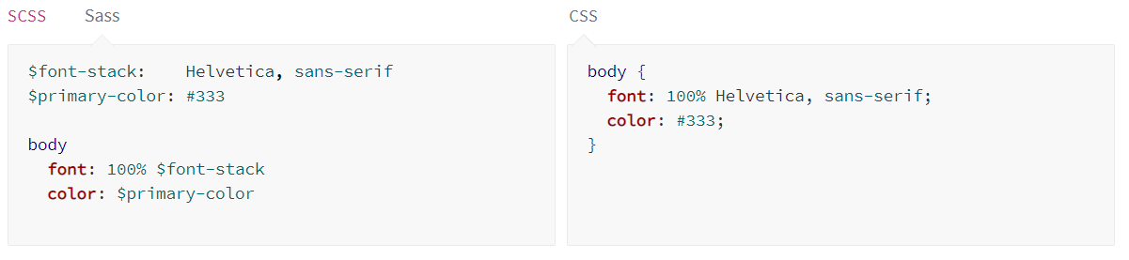
Типы переменных

■ string (e.g. "Hello world", kittens)

■ number (e.g. 42, 1337px)

■ color (e.g. hotpink, rgb(1, 33, 7), #BADA55)
■ list (e.g. (a, b, c), a b c)
■ map (e.g. (a: 1, b: 2))
■ bool (true or false)
■ null (null)

To know the type of a Sass variable, we use the type-of(..) built-in function.

Иерархия
Препроцессор позволяет записывать стили в ирерахии похожей на HTML
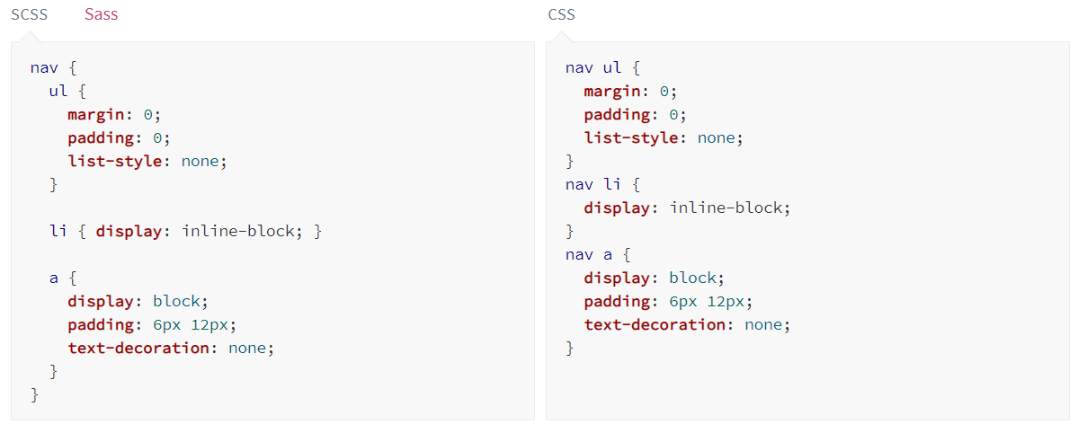
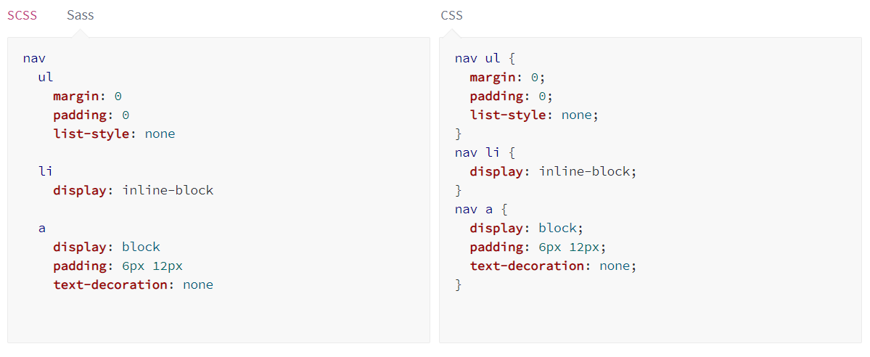
You'll notice that the ul, li, and a selectors are nested inside the nav selector. This is a great way to organize your CSS and make it more readable.

Partials (части кода)
You can create partial Sass files that contain little snippets of CSS that you can include in other Sass files. This is a great way to modularize your CSS and help keep things easier to maintain.
A partial is a Sass file named with a leading underscore. You might name it something like _partial.scss.
The underscore lets Sass know that the file is only a partial file and that it should not be generated into a CSS file. Sass partials are used with the @use rule.
@use должно находится выше всех правил.
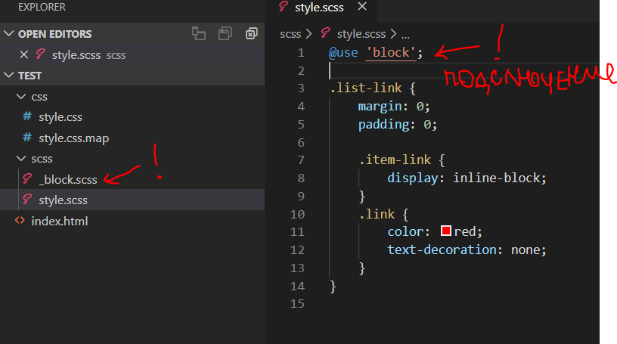

Modules (Модули)
You don't have to write all your Sass in a single file. You can split it up however you want with the @use rule. This rule loads another Sass file as a module, which means you can refer to its variables, mixins, and functions in your Sass file with a namespace based on the filename.
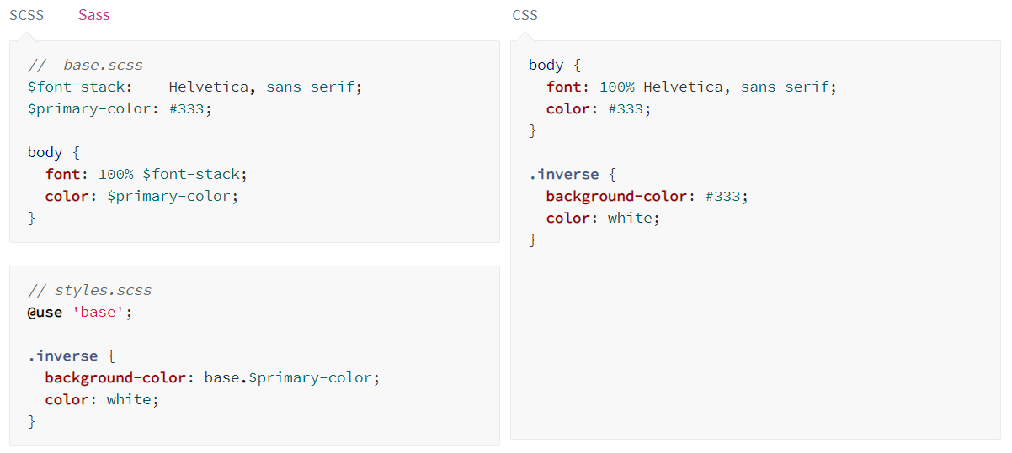
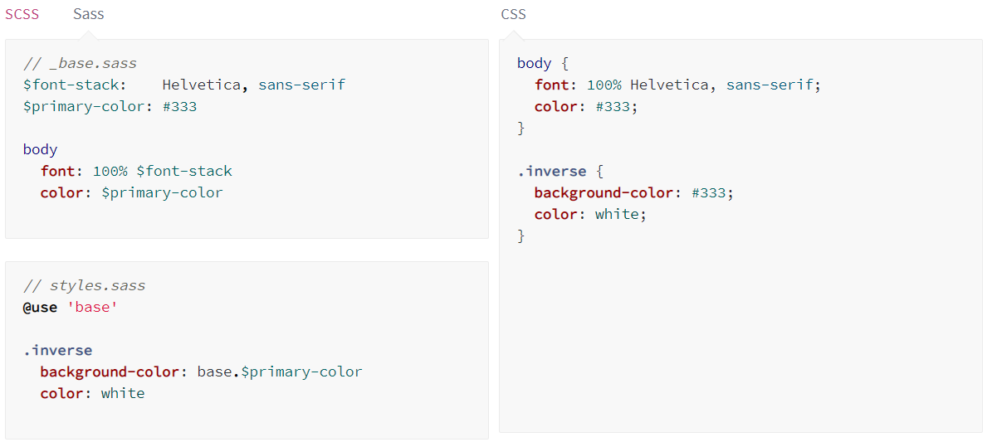
Notice we're using @use 'base'; in the styles.scss file. When you use a file you don't need to include the file extension!!!!!!

Mixins
Some things in CSS are a bit tedious to write, especially with CSS3 and the many vendor prefixes that exist. A mixin lets you make groups of CSS declarations that you want to reuse throughout your site. You can even pass in values to make your mixin more flexible. A good use of a mixin is for vendor prefixes. Here's an example for transform.
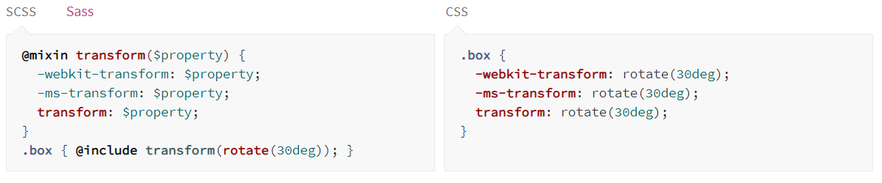
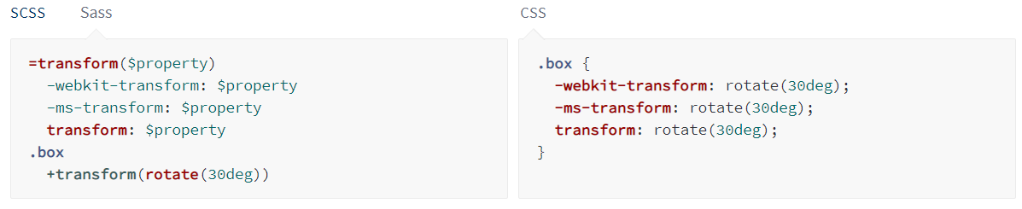
To create a mixin you use the @mixin directive and give it a name. We've named our mixin transform. We're also using the variable $property inside the parentheses so we can pass in a transform of whatever we want. After you create your mixin, you can then use it as a CSS declaration starting with @include followed by the name of the mixin.

Extend/Inheritance
This is one of the most useful features of Sass. Using @extend lets you share a set of CSS properties from one selector to another.
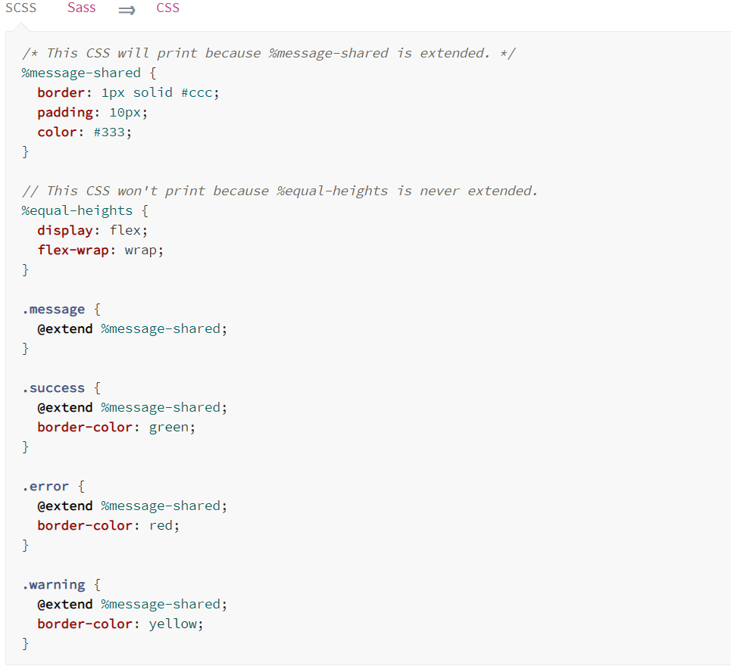
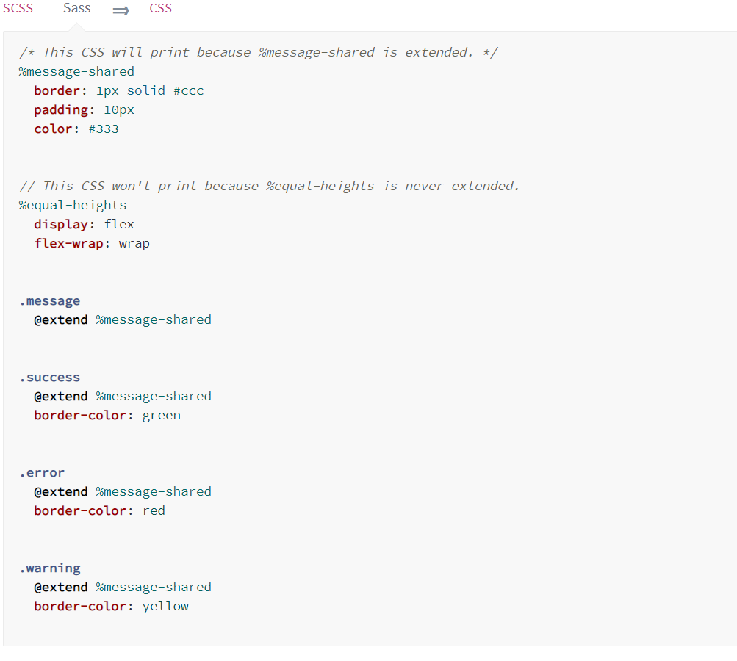
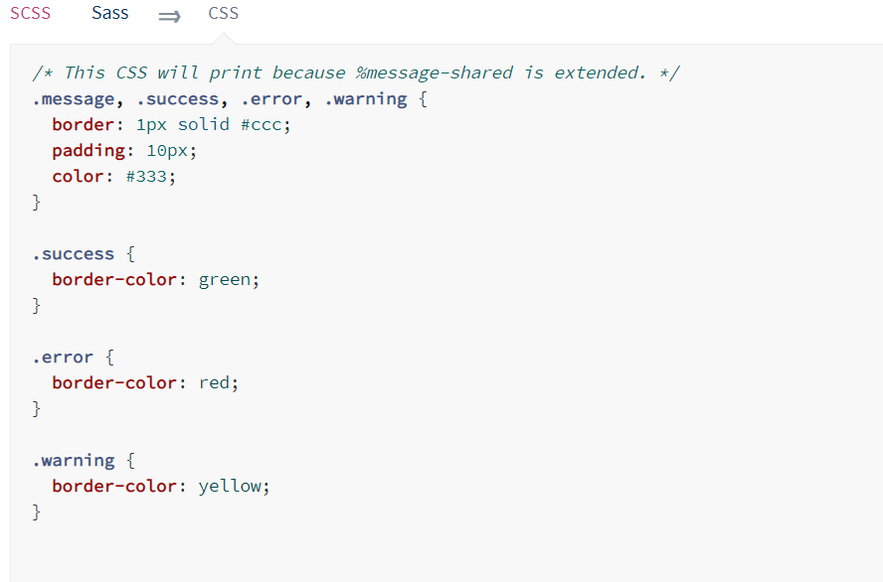
What the above code does is tells .message, .success, .error, and .warning to behave just like %message-shared. That means anywhere that %message-shared shows up, .message, .success, .error, & .warning will too.

Operators
Doing math in your CSS is very helpful. Sass has a handful of standard math operators like +, -, *, /, and %. In our example we're going to do some simple math to calculate widths for an aside & article.
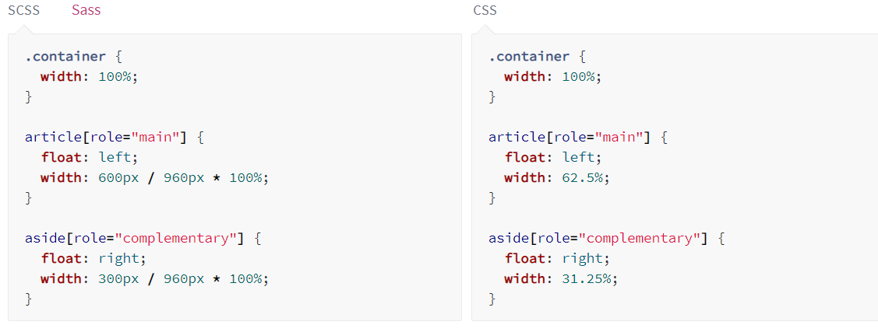
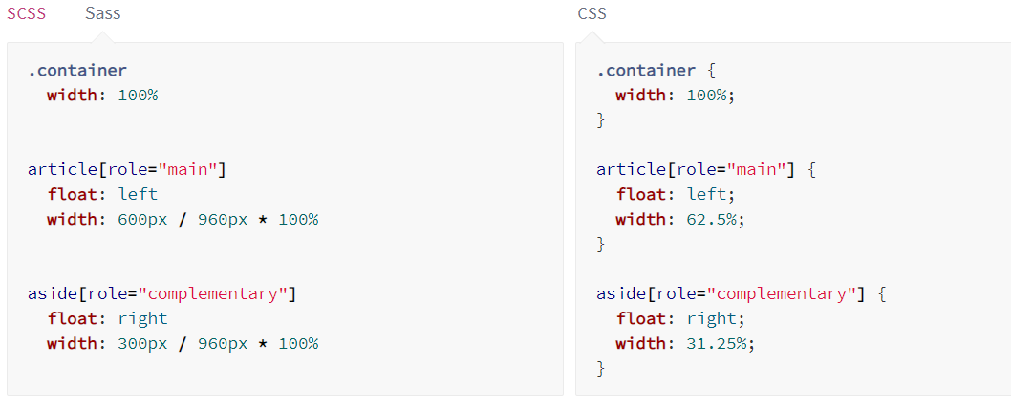
Деление работает в Sass не так как в обычно в программировании. Это связано с тем что символ / используется в сокращенных записях css правил, поэтому деление работает в перечисленных ниже случаях:
■ If the value, or any part of it, is stored in a variable or returned by a function.
■ If the value is surrounded by parentheses.
■ If the value is used as part of another arithmetic expression.
Например:
